

Error Free Text

Learn Linux commands with   
Error free text | Graduation Project | 2023.

FINAL YEAR GRADUATION PROJECT



Department of Computer Science

Faculty Information Technology and Computer Science Yarmouk University

Irbid, Jordan

*BSc Project*

*CYS Department*

*Project ID: 2023-06-08-01*



Error Free Text

## Learn Linux commands with Error free text

**Muhannd Baker Alqudah, 2019804057**  
**Yazan Shannek, 2019904128**  
**Mohammad Aldakhnoush, 2019904196**  
**Zohoor Alsowi, 2019904075**  
**Dana Abo Alnasser, 2019904181**

Department of Information Technology/ Cybersecurity program Faculty Information Technology and Computer Science Yarmouk University

Irbid, Jordan

***Contact Information***

*This project report is submitted to the Department of Information Technology/ Cybersecurity program at Yarmouk University in partial fulfillment of the requirements for the degree of Bachelor of Information Technology in Cybersecurity.*

##### Author(s):

*Muhannd baker alqudah ,2019804057*

*Address: Ajloun*

*E-mail:* [*muhanndbakeralqudah@gmail.com*](mailto:muhanndbakeralqudah@gmail.com <muhanndbakeralqudah@gmail.com>)

*Yazan shannek,2019904128*

*E-mail:* [*yazanshannek10@gmail.com*](mailto:yazanshannek10@gmail.com)

*Address: Irbid*

*Mohammad aldakhnoush,2019904128*

*E-mail:* [*Mohmmadbaniameer12345@gmail.com*](http://1)

*Address: Irbid*

*Zohoor alsowi,201904075*

*Address: Jerash*

*E-mail:* [Sowishatha@gmail.com](mailto:Sowishatha@gmail.com)

*Dana abo alnasser,2019904181*

*E-mail:* [*Danatabulnasser@gmail.com*](mailto:Danatabulnasser@gmail.com)

*Address: Irbid*

##### University supervisor(s):

*ENG. Shatha shakhatreh*

*Information Technology/ Cybersecurity program*

***University supervisor(s):***

*ENG. Shatha shakhatreh*

*Department of Information Technology/*

*Cybersecurity program Internet:* [*http://yu.edu.jo*](http://yu.edu.jo/)

*Faculty of Information Technology Phone: +962 2 72711111 Ext. 2634 and Computer Sciences*

*Yarmouk University Fax: +962 2 7211111 Jordan*

***Intellectual Property Right Declaration***

This is to declare that the work under the supervision of Eng. Shatha shakhatreh having the title “Phishing Detection” carried out in partial fulfillment of the requirements of Bachelor of Information Technology in Cybersecurity is the sole property of the Yarmouk University and the respective supervisor and is protected under the intellectual property right laws and conventions. It can only be considered/ used for purposes like an extension for further enhancement, product development, commercial/organizational usage adoption, etc., with the university’s respective supervisor's permission visor.

*Date:* ***05/06/2023***

|  |  |  |  |  |  |  |  |  |  |  |  |
| --- | --- | --- | --- | --- | --- | --- | --- | --- | --- | --- | --- |
|  | |  |  | | --- | --- | | *Name:* Muhannd alqudah | *Signature:* | | *Name:* Yazan alshannek | *Signature:* | | *Name: Zohoor alswoi* | *Signature:* |  |  |  | | --- | --- | | *Name:Mohammadahknoush* | *Signature:* |  |  |  | | --- | --- | | *Name: Dana abo alnasser* | *Signature:* | |

***Supervisor(s):***

*Dr. Shatha shakhatreh Signature:*

***Anti-Plagiarism Declaration***

This is to declare that the above publication produced under the supervision of “ENG. Shatha shakhatreh” having title “Syntax checker command” is the sole contribution of the author(s) and no part hereof has been reproduced illegally (cut and paste) which can be considered as Plagiarism. All referenced parts have been used to argue the idea and have been cited properly. I/We will be responsible and liable for any consequence if violation of this declaration is proven..

Date: ***05/06/2023***

**Author(s):**

|  |  |
| --- | --- |
| *Name:* Muhannd alqudah | *Signature:* |
| *Name:* Yazan alshannek | *Signature:* |
| *Name: Zohoor alswoi* | *Signature:* |

|  |  |
| --- | --- |
| *Name:Mohammadahknoush* | *Signature:* |

|  |  |
| --- | --- |
| *Name: Dana abo alnasser* | *Signature:* |

# DEDICATION

We offer our special thanks and love to our families for their support, patience, and encouragement without whom nothing would have been possible for us and we would have not reached this far.

# ACKNOWLEDGMENT

Praise be to Allah Lord of all creation for his unending grace.

We would like to express our special thanks of gratitude to Eng . Shatha shakhatreh, our esteemed supervisors, for their patience and guidance throughout the production of this project and who helped every step of the way.

- Error free text

Table of Contents

ABSTRACT 11

CHAPTER ONE 12

1. INTRODUCTION 12
   1. Project Overview 12
   2. About Linux Operating System 14
   3. About Linux Command-Line 14
   4. Problem Statement 15

CHAPTER TWO 16

1. Background 16
   1. Related work 16

CHAPTER THREE 44

* 1. System Design 44
  2. Benefit to Society 47

CHAPTER FOUR 48

4. C Pseudocode 48

CHAPTER FIVE 48

5. Testing and result 48

CHAPTER SIX 48

5. CONCLUSION 48

REFERENCES 49

## ABSTRACT

##### With the rapid expansion of technology and the education sector emerging as one of the largest industries worldwide, the importance of cybersecurity has become a pressing need. In response to this demand, we have developed a comprehensive training website that offers a series of tests to help individuals understand and master command line commands.

##### 

##### 

##### Our platform aims to equip trainees with the necessary skills and knowledge to navigate the intricacies of command line interfaces. By providing a range of tests, we offer a hands-on learning experience that allows users to practice executing commands, managing files and directories, and performing various administrative tasks.

##### 

##### 

##### 

##### Moreover, we recognize the significance of security in today's digital landscape. Therefore, our training site incorporates essential security principles and best practices into the command line training modules. Trainees will not only gain proficiency in command line operations but also understand the importance of maintaining data confidentiality, integrity, and availability

**CHAPTER ONE**

#### INTRODUCTION

#### Project Overview

Welcome to the introduction of our project, a dedicated website that serves as an interactive learning platform for mastering Linux command-line skills, specifically focused on security-related commands. Our platform provides comprehensive tutorials and practical exercises to enhance users' understanding and proficiency in commands such as "chmod," "chown," "chgrp," "adduser," "passwd," "deluser," "sudo," and "su."

* + 1. **Project Objectives**

Our project aims to empower individuals to develop and enhance their command-line skills in Linux, particularly in the context of security. We have created a website that offers a series of tests designed to assess users' abilities and aid in the development of their Linux command-line capabilities. Through our platform, users can explore a range of commands and experience their functionalities via a simulated terminal interface, which we have meticulously designed and developed.

* + 1. **Learning through Tests**

Our platform features a collection of tests that enable users to evaluate their knowledge and skill levels in Linux command-line security commands. These tests provide an immersive learning experience, allowing users to practice executing various commands and honing their abilities. By engaging with the tests and actively experimenting with the commands within the simulated terminal interface, users can gauge their progress and identify areas for improvement.

* + 1. **Advancing Skills and Development**

Our platform is designed to support users in their journey to develop and enhance their Linux command-line skills. By engaging with the tests and practicing the commands, users can boost their proficiency, gain confidence, and foster a deeper understanding of Linux security commands. Through continuous practice and exploration, users can unlock their full potential and become adept at utilizing these commands effectively.

#### About Linux Operating System

Linux is gaining increasing attention nowadays due to its flexibility and robustness in handling systems and data. Linux is an open-source and free operating system widely used across a variety of devices and platforms. It is known for its stability, security, adaptability, and compatibility with multiple technologies. Linux is extensively used in servers, laptops, smartphones, and other electronic devices.

Benefits of Linux Operating System:

Being an open-source system, Linux allows developers to modify, customize, and enhance it according to their specific needs.

Linux offers a vast array of distributions and software options, providing users with a wide range of choices and flexibility.

Linux is known for its stability and reliability, making it a preferred choice for critical systems and server environments.  
  
The robust security features of Linux make it less prone to malware and cyber-attacks compared to other operating systems.

Linux has a vibrant and supportive community of developers and users who contribute to its continuous improvement and provide assistance through forums and online resources.

Overall, Linux stands as a powerful operating system that continues to evolve and thrive, offering users a stable, secure, and customizable platform for various computing.

#### About Linux Command-Line

In the world of Linux, the command-line interface (CLI) serves as a powerful tool that empowers users to interact with the operating system at a deeper level. While graphical user interfaces (GUIs) provide a user-friendly experience, mastering Linux command-line commands opens up a world of possibilities, efficiency, and enhanced security. This documentation focuses on the significance and benefits of using Linux commands, particularly in relation to security, within our project.

Security is a paramount concern in today's digital landscape, and Linux has gained a reputation for its robust security features. By leveraging Linux command-line capabilities, we can enhance the security of our systems and protect sensitive data from unauthorized access and potential threats. Here, we delve into the crucial role that Linux commands play in fortifying security framework:

* + 1. **Access Control and Permissions**

Linux commands allow us to establish granular access controls and set file permissions with precision. By using commands like "chmod" and "chown," we can assign specific permissions to files and directories, ensuring that only authorized users can access, modify, or execute them. Implementing strict access controls is fundamental to maintaining data integrity and preventing unauthorized access.

* + 1. **User Management**

With Linux commands, we can effectively manage user accounts and their associated privileges. Commands such as "adduser," "deluser," and "passwd" enable us to create, remove, and modify user accounts, set password policies, and enforce strong authentication mechanisms. By properly managing user accounts, we can reduce the risk of unauthorized access and potential security breaches.

* + 1. **Network Security**

Linux commands provide robust networking capabilities to secure our systems in networked environments. For instance, commands like "iptables" allow us to configure firewall rules, filter network traffic, and create secure perimeters for our project. Additionally, tools like "netstat" and "nmap" enable us to monitor network connections, identify potential vulnerabilities, and ensure the integrity of our network communications.

* + 1. **System Hardening:**

Linux commands aid in system hardening by allowing us to implement security measures that protect against common attack vectors. By using commands like "ufw" or "iptables," we can restrict network services, block unauthorized access attempts, and create a layered defense mechanism. Moreover, commands such as "auditd" facilitate auditing and monitoring of system activities, ensuring compliance and early detection of potential security incidents.

#### Problem Statement

The problem our project addresses is the limited availability of practical assessment opportunities for individuals to test their knowledge and skills in Linux command-line security. While there are resources that offer tutorials and theoretical explanations of these commands, there is a lack of platforms that focus solely on providing interactive tests to evaluate one's proficiency in using these commands effectively. This creates a challenge for individuals to gauge their understanding and competency in Linux command-line security, potentially leaving them unprepared to handle security risks. Our project aims to solve this problem by providing a dedicated platform that offers a wide range of assessments specifically designed to evaluate a user's knowledge and practical application of Linux command-line security commands. Through our website, users can access a variety of tests that simulate real-world scenarios, allowing them to apply their skills and make informed decisions in a secure environment. By providing a comprehensive set of assessments, our project equips users with the means to identify their strengths and weaknesses in using these commands and take steps to improve their security capabilities.

By offering a user-friendly interface and a diverse range of test scenarios, our project aims to bridge the gap between theoretical knowledge and practical proficiency in Linux command-line security. Through our assessments, users can assess their readiness to handle security challenges and develop the necessary skills to mitigate potential risks effectively. Ultimately, our project seeks to enhance the overall security awareness and preparedness of individuals by providing them with a platform to test and validate their Linux command-line security expertise

### CHAPTER TWO

#### Background

A platform that teaches users to test code writing at many levels, from beginner mode to advanced mode and even professional mode, is the syntax checker command service and platform. Using a variety of examples, exercises, and exams where you earn points to gauge your proficiency in actual tests, the syntax checker command assists you in achieving the required outcomes.

The syntax checker command platform's main goal is to make it easier for everyone to learn how to write linux commands correctly and securely. Without the need to test it first using unethical methods or on platforms that might jeopardize the safety of the platform or your device,  
  
Why do people use the command line?

Although using a command-line interface requires the memorization of many different commands, it can be valuable resource and should not be ignored. Using a command line, you can perform almost all the same tasks that can be done with a GUI. However, many tasks can be performed quicker and can be easier to automate and do remotely.

Advantages of syntax checker command:

**Open-Source Nature**, what is it like when you buy a car, but you cannot see what’s under the hood? Similar is the case with when you use a Windows-powered system..

**Secure**, let’s face it; Windows OS is vulnerable to different types of attacks (or hacks). However, Linux is not as vulnerable as Windows. It sure isn’t invulnerable, but it is a lot more secure. Although, there’s no rocket science in it.

**Free to Use (Low Cost)**, is freely available on the web to use. You do not need to buy the license for it as and many of its software come with GNU General Public License.

#### Related work

#### Like the “Try Hack Me” platform, it is a platform that teaches the school to test penetration at different levels, from beginner mode through advanced mode, and even professionalism as well. Try to search for the desired results through a group of titles, as well as exercises, and games in which you collect points and brag about them on the rest of the topics.

#### The basic principle behind the Try Hack Me platform is to open the way for everyone to learn hacking techniques properly and safely. Without having to try it, you can try it illegally, or another platform, and another platform, your security is second to you.

#### PROBLEM

#### One of the main problems with Try Hack Me is that it may not be suitable for everyone. The website is designed for people who want to learn about cybersecurity and ethical hacking, and it may not be suitable for people who do not have an interest in these topics. Additionally, some of the challenges and virtual rooms on the website may be too difficult for beginners, which could be discouraging. Another problem is that some of the challenges may be outdated or no longer relevant, which could be frustrating for users who are looking for up-to-date information. Finally, although Try Hack Me provides a safe and legal environment for users to practice their hacking skills, some people may still have concerns about the ethical implications of hacking.

#### METHOLOGY

#### The methodology of Try Hack Me involves providing various cybersecurity challenges and virtual rooms to help users learn and practice their hacking skills in a safe and legal environment. The website offers a range of rooms that are designed to cater to users with different levels of experience. These rooms include beginner-level rooms that cover basic concepts of cybersecurity, as well as more advanced rooms that focus on specific topics such as web application security, reverse engineering, and cryptography. The website also provides users with an online platform to communicate with other users and share their experiences.

#### RESULT

#### Try Hack Me is an online platform that provides users with a range of challenges and virtual rooms to practice their hacking skills. The website is designed to help users learn about cybersecurity and ethical hacking, and it provides a safe and legal environment for users to practice their skills. The results of using Try Hack Me will depend on the user's goals and level of experience. Some users may be able to improve their cybersecurity skills significantly by using the website, while others may find that they need additional resources or support to achieve their goals. Overall, Try Hack Me is a valuable resource for anyone interested in learning more about cybersecurity and ethical hacking.

#### DISADVANTAG

#### One of the main disadvantages of Try Hack Me is that it may not be suitable for everyone. The website is designed for people who want to learn about cybersecurity and ethical hacking, and it may not be suitable for people who do not have an interest in these topics. Additionally, some of the challenges and virtual rooms on the website may be too difficult for beginners, which could be discouraging. Another disadvantage is that some of the challenges may be outdated or no longer relevant, which could be frustrating for users who are looking for up-to-date information. Finally, although Try Hack Me provides a safe and legal environment for users to practice their hacking skills, some people may still have concerns about the ethical implications of hacking.

#### CHAPTER THREE:

#### System Design

A data flow diagram (DFD) is a graphical representation of data flow through a system. It’s employed to understand how data is processed, stored, and communicated within a system. Moreover, DFD is used to support the analysis of how the data flows in existing or proposed systems from one page or module to another (using a flowchart). It’s also called a bubble chart.

In this tutorial, we’ll learn the basics of DFD, its purpose, components, levels, and how to create a DFD.[1]

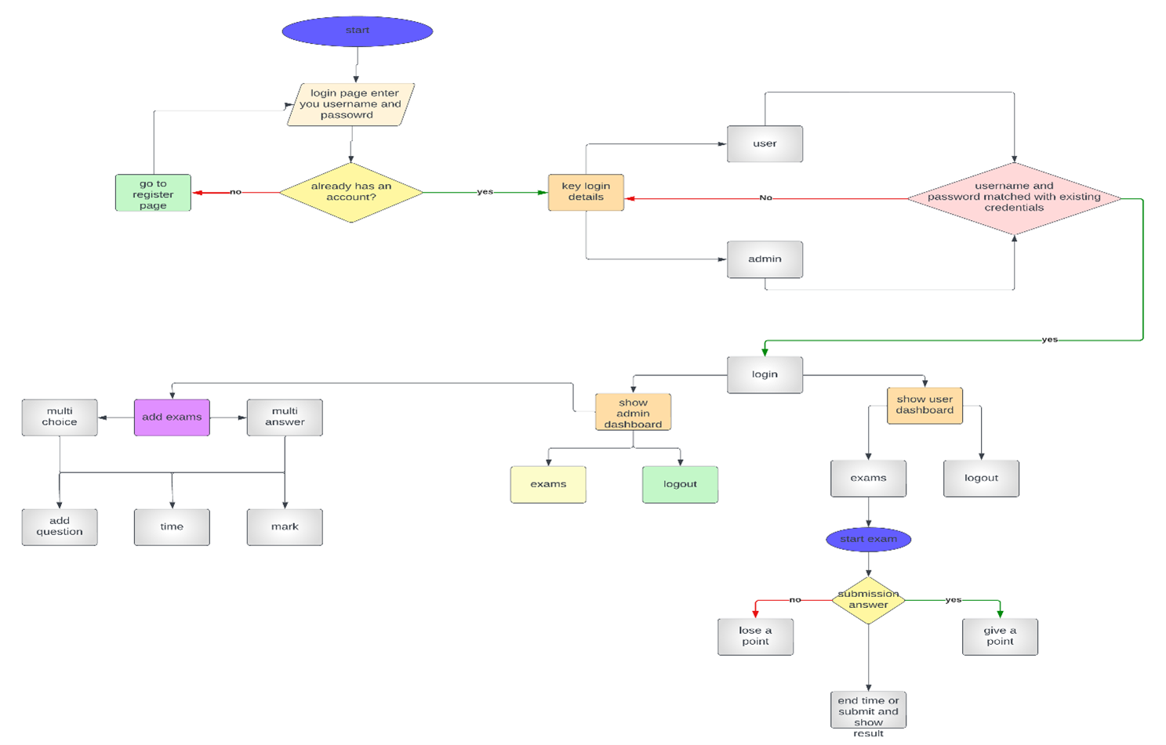

### CHAPTER FOUR

### Pseudocode

### PSEUDOCODE:

### Exam function

#### ExamController: examService: ExamService constructor(examService: ExamService): this.examService = examService getAll(): ResponseEntity<List<Exam>> exams: List<Exam> = examService.getAll() return new ResponseEntity<>(exams, HttpStatus.OK) get(id: Long): ResponseEntity<Exam> exam: Optional<Exam> = examService.get(id) return [exam.map](http://exam.map/)(value -> new ResponseEntity<>(examService.emptyAnswers(value), HttpStatus.OK)) .orElseGet(() -> new ResponseEntity<>(new Exam(), HttpStatus.NOT_FOUND)) save(exam: Exam) [examService.save](http://examservice.save/)(exam) submit(exam: Exam, userId: Long) examService.calculate(exam, userId)

ExamService:   
 examRepository: ExamRepository   
 userExamRepository: UserExamRepository   
   
 constructor(examRepository, userExamRepository):   
 this.examRepository = examRepository   
 this.userExamRepository = userExamRepository   
   
 get(id: Long): Optional<Exam>   
 return examRepository.findById(id)   
   
 save(exam: Exam)   
 [examRepository.save](http://examrepository.save/)(exam)   
   
 calculate(submission: Exam, userId: Long)   
 mark: AtomicLong = 0   
 maxMark: AtomicLong = 0   
 exam: Exam = examRepository.findById(submission.getId()).get()   
 calculateMultiChoice(submission, mark, maxMark, exam)   
 calculateTextQuestions(submission, exam, mark, maxMark)   
 userExam: UserExam = UserExam()   
 userExam.setExam(submission)   
 userExam.setUserId(userId)   
 userExam.setUserMark(mark.longValue())   
 [userExamRepository.save](http://userexamrepository.save/)(userExam)   
   
 calculateTextQuestions(submission: Exam, exam: Exam, mark: AtomicLong, maxMark: AtomicLong)   
 textQuestions: List<TextQuestion> = submission.getTextQuestions()   
 answers: List<TextQuestion> = exam.getTextQuestions()   
 for index in range(textQuestions.size()):   
 question: TextQuestion = textQuestions.get(index)   
 if question.getAnswer().equals(answers.get(index).getAnswer()):   
 mark.addAndGet(question.getQuestionMark())   
 maxMark.addAndGet(question.getQuestionMark())   
   
 calculateMultiChoice(submission: Exam, mark: AtomicLong, maxMark: AtomicLong, exam: Exam)   
 multiChoiceQuestions: List<MultiChoiceQuestion> = submission.getMultiChoiceQuestions()   
 answers: List<MultiChoiceQuestion> = exam.getMultiChoiceQuestions()   
 for index in range(multiChoiceQuestions.size()):   
 userAnswer: MultiChoiceQuestion = multiChoiceQuestions.get(index)   
 answer: MultiChoiceQuestion = answers.get(index)   
 for option in range(userAnswer.getOptions().size()):   
 userOption: QuestionOption = userAnswer.getOptions().get(option)   
 questionOption: QuestionOption = answer.getOptions().get(option)   
 if userOption.isCorrect() and questionOption.isCorrect():   
 mark.addAndGet(answer.getQuestionMark())   
 maxMark.addAndGet(answer.getQuestionMark())   
   
 getAll(): List<Exam>   
 return examRepository.findAll()   
   
 emptyAnswers(exam: Exam): Exam   
 textQuestions: List<TextQuestion> = exam.getTextQuestions()   
 for textQuestion in textQuestions:   
 textQuestion.setAnswer("")   
 exam.setTextQuestions(textQuestions)   
   
 multiChoiceQuestions: List<MultiChoiceQuestion> = exam.getMultiChoiceQuestions()   
 for multiChoiceQuestion in multiChoiceQuestions:   
 options: List<QuestionOption> = multiChoiceQuestion.getOptions()   
 for option in options:   
 option.setCorrect(false)   
 multiChoiceQuestion.setOptions(options)   
 exam.setMultiChoiceQuestions(multiChoiceQuestions)   
   
 return exam

**User function**

UserController:

userService: UserService

constructor(userService: UserService):

this.userService = userService

login(request: LoginRequest): ResponseEntity<?>

login: LoginResponse = userService.login(request)

if Objects.equals(login.getStatusCode(), "200"):

return new ResponseEntity<>(login, null, HttpStatus.ACCEPTED)

else:

return new ResponseEntity<>(login, null, HttpStatus.UNAUTHORIZED)

register(request: RegisterRequest): RegisterResponse

return userService.register(request)

get(id: Long): User

return userService.get(id)

getExams(id: Long): List<UserExam>

return userService.getExams(id)

UserService:   
 userRepository: UserRepository

userExamRepository: UserExamRepository

stringHelper: StringHelper

constructor(userRepository: UserRepository, userExamRepository:

UserExamRepository, stringHelper: StringHelper):

this.userRepository = userRepository

this.userExamRepository = userExamRepository

this.stringHelper = stringHelper

login(request: LoginRequest): LoginResponse

user: Optional<User> = userRepository.findByEmail(request.getEmail())

loggedIn: boolean = user.isPresent()

if loggedIn:

loggedIn = stringHelper.equals(request.getPassword(),

user.get().getPassword())

if !loggedIn:

return [LoginResponse.build](http://loginresponse.build/)(false, null)

session: Session = startSession(user.get().getId())

return new LoginResponse("200", "Logged In", session, user.get())

startSession(id: Long): Session

return new Session(id)

register(request:RegisterRequest):RegisterResponse   
 request.setPassword(stringHelper.encode(request.getPassword()))   
 user:User=newUser(request.getEmail(),request.getPassword(), request.getFirstName(),request.getLastName(), Timestamp.valueOf([LocalDateTime.now](http://localdatetime.now/)()))   
 [userRepository.save](http://userrepository.save/)(user)   
 return new RegisterResponse("200", "Registered", new UserResponse(user))   
 get(id:Long):User   
 user:Optional<User>=userRepository.findById(id)   
 returnuser.orElseThrow()   
   
 getExams(id:Long):List<UserExam>   
 return userExamRepository.findAllByUserId(id)

**function login**

function login(request): user = userRepository.findByEmail(request.getEmail())  
 loggedIn = user.isPresent() && stringHelper.equals(request.getPassword(), user.getPassword())   
 if loggedIn: session = startSession(user.getId())  
 response = new LoginResponse("200", "Logged In", session, user) else:  
 response = [LoginResponse.build](http://loginresponse.build/)(false, null)   
 return response  
function startSession(userId): session = new Session(userId)  
 return session  
function register(request): hashedPassword = stringHelper.encode(request.getPassword())  
 user = new User(request.getEmail(), hashedPassword, request.getFirstName(), request.getLastName(), [LocalDateTime.now](http://localdatetime.now/)()) [userRepository.save](http://userrepository.save/)(user)  
 response = new RegisterResponse("200", "Registered", new UserResponse(user)) return response  
function get(id):  
 user = userRepository.findById(id) return user  
function getExams(id):  
 exams = userExamRepository.findAllByUserId(id) return exams

**CHAPTER FIVE**

Testing and result

Test code:

Run pash code containers to connect with docker

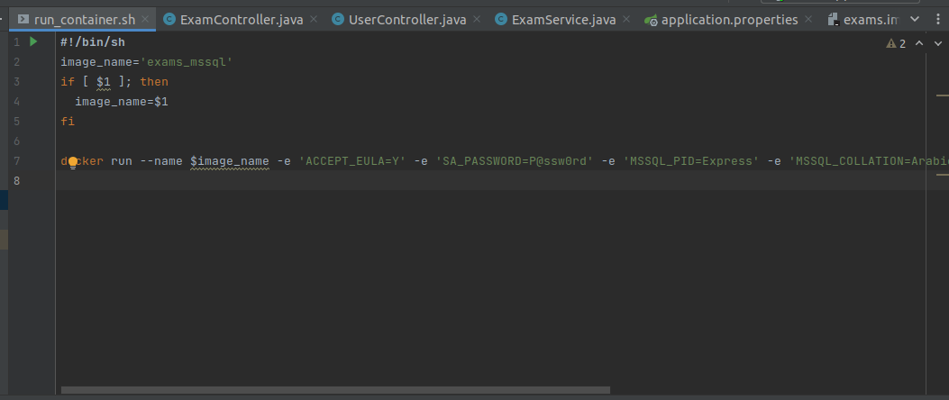

**Connect with docker:**

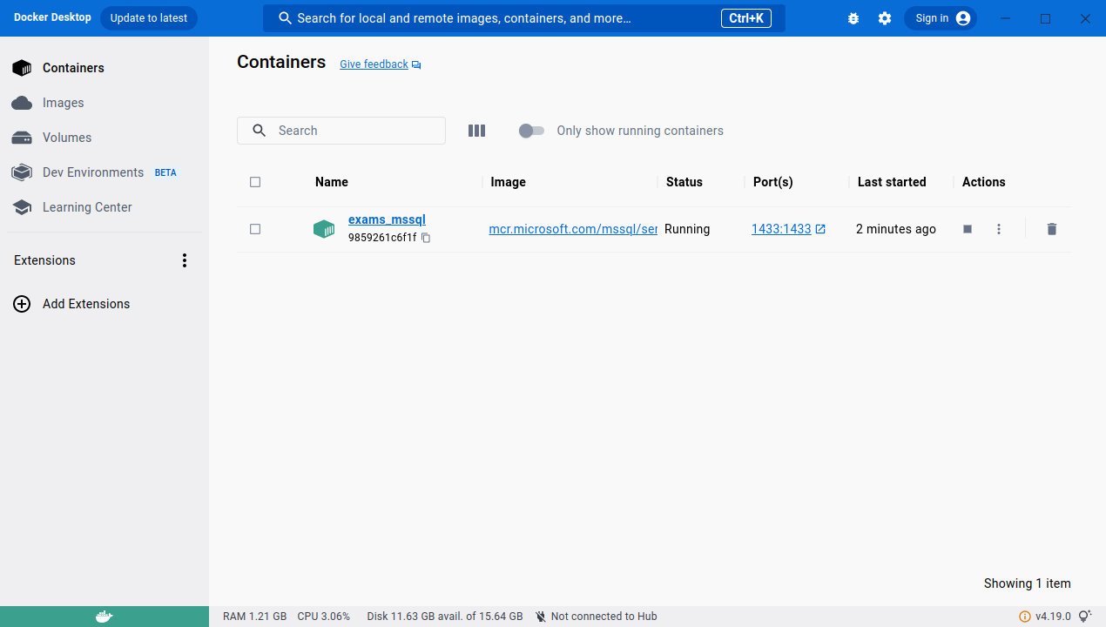

RUN BACKEND CODE ON INTELLIJ

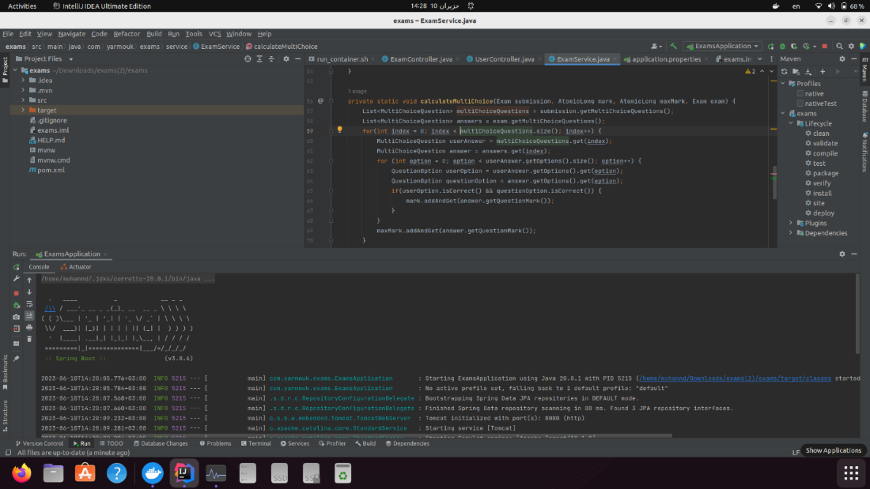

RUN FRONTEND ON VISUAL STUDIO

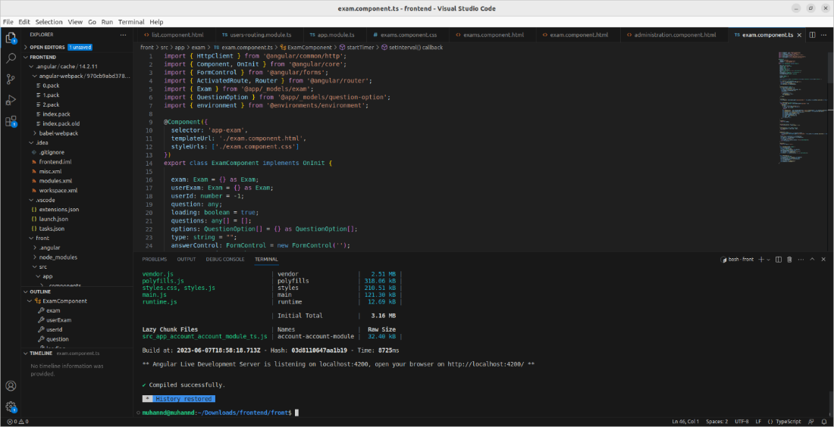

INTERFACE GUI LOGIN

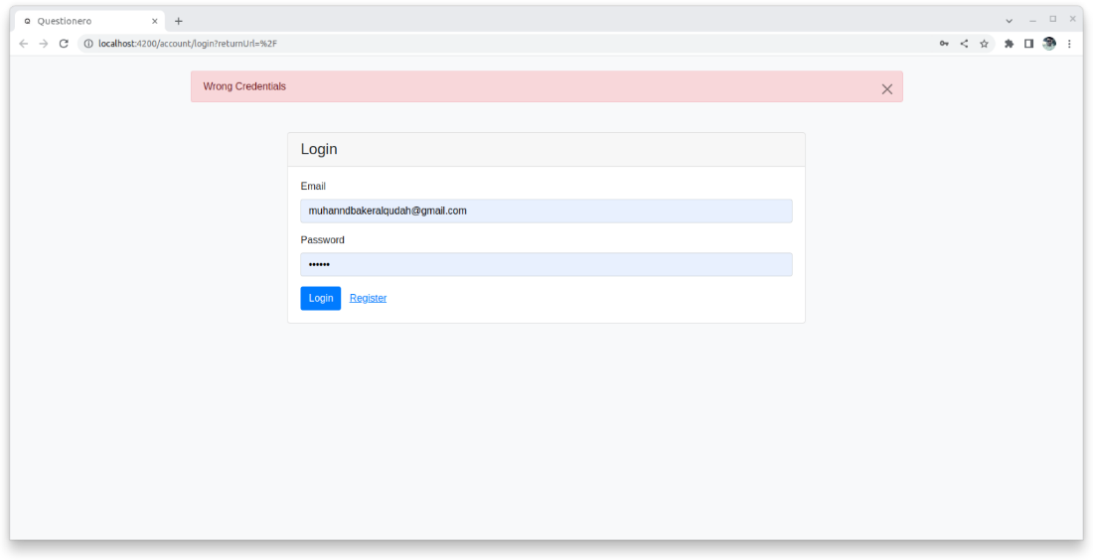

PAGE REGISTER USER

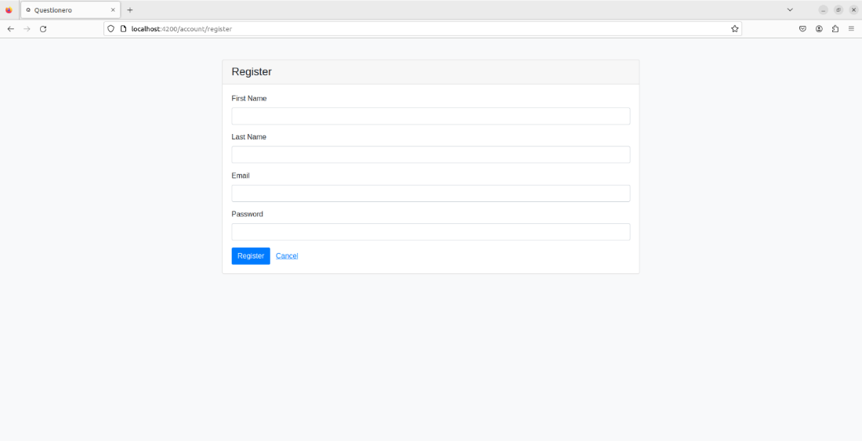

DASHPOARD ADMIN

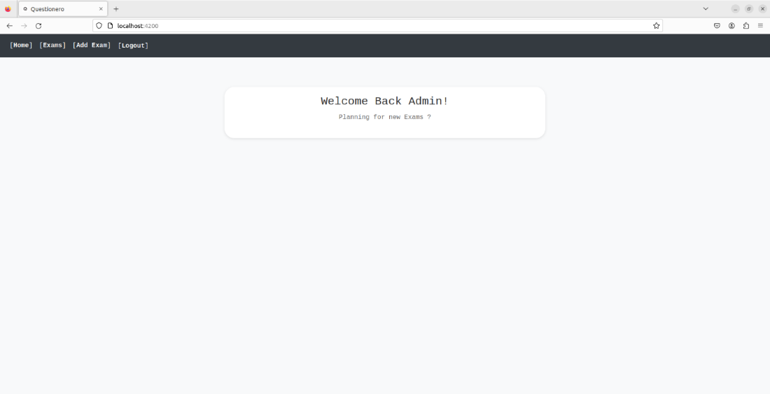

ADD EXAMS

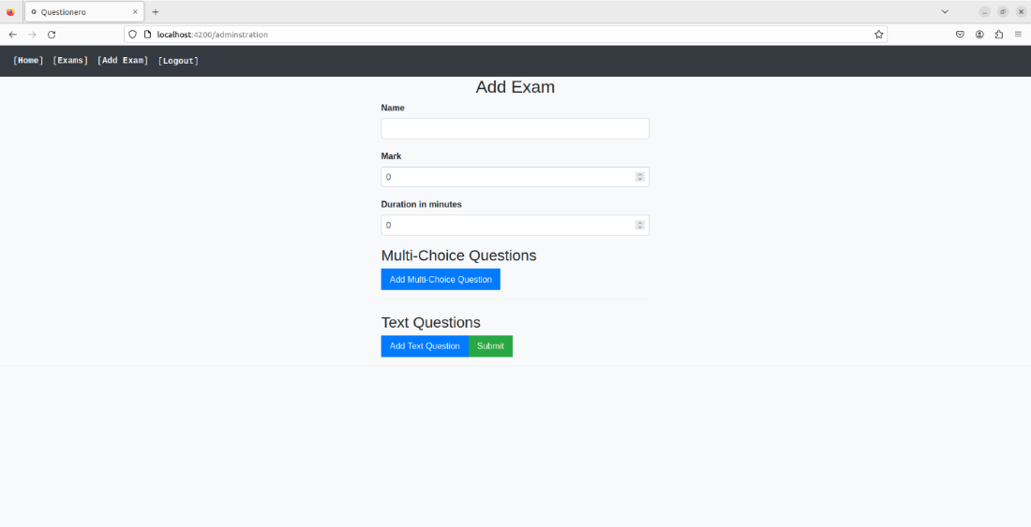

ADD MULTICHOICE QUESTION

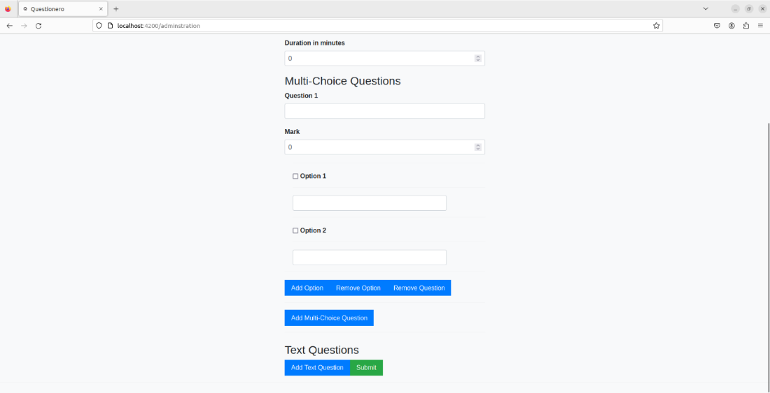

ADD TEXT QUESTION

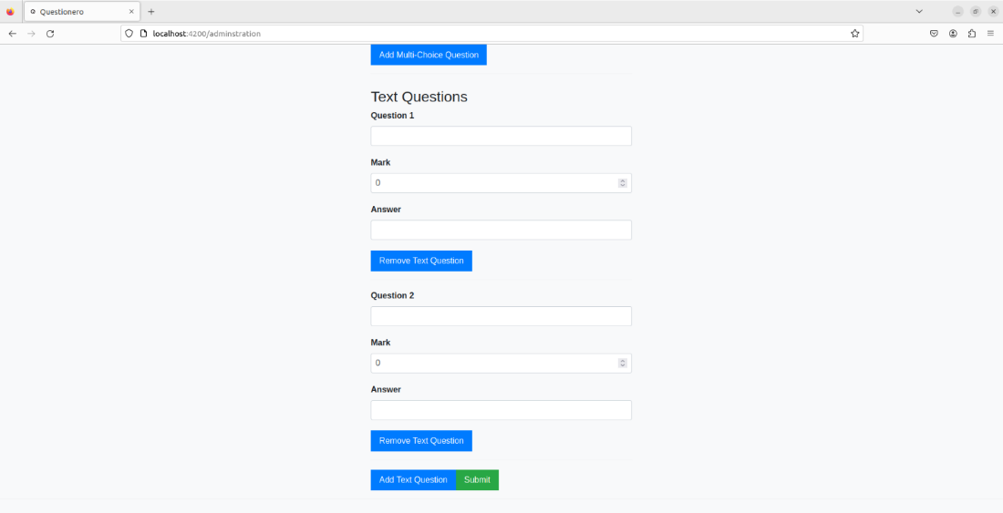

Dash board user

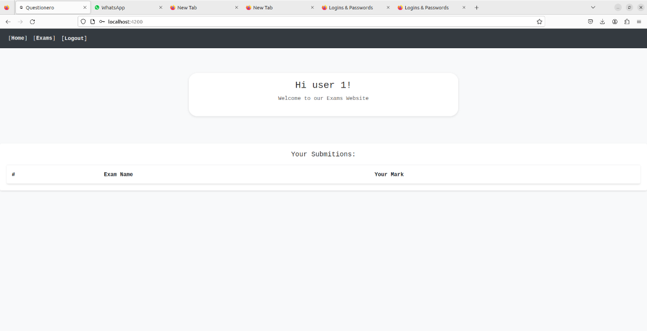

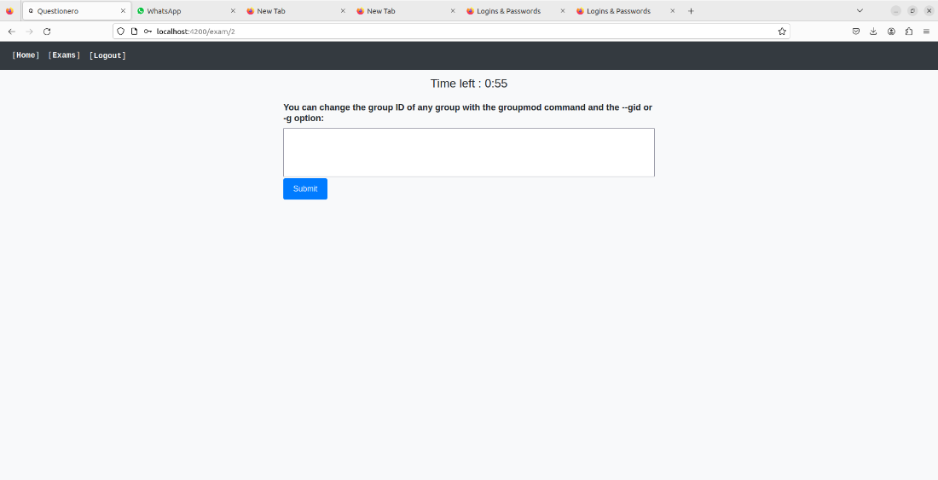

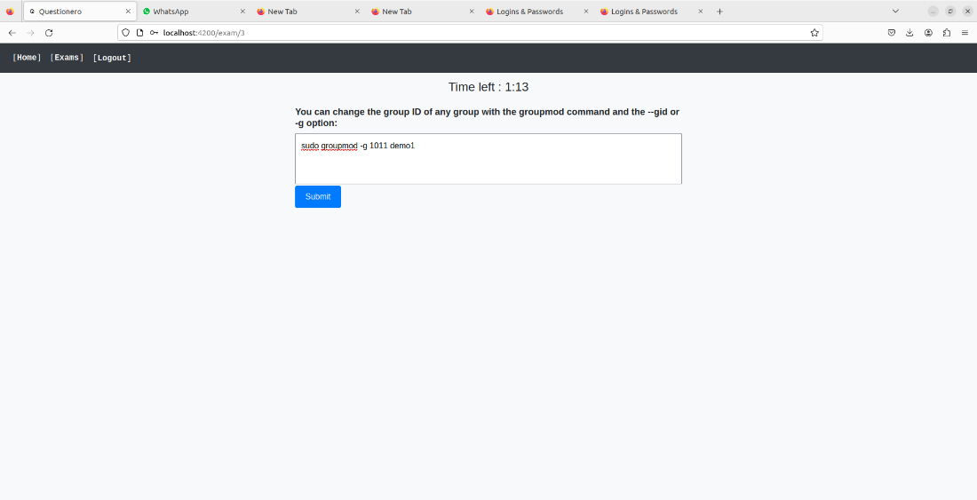

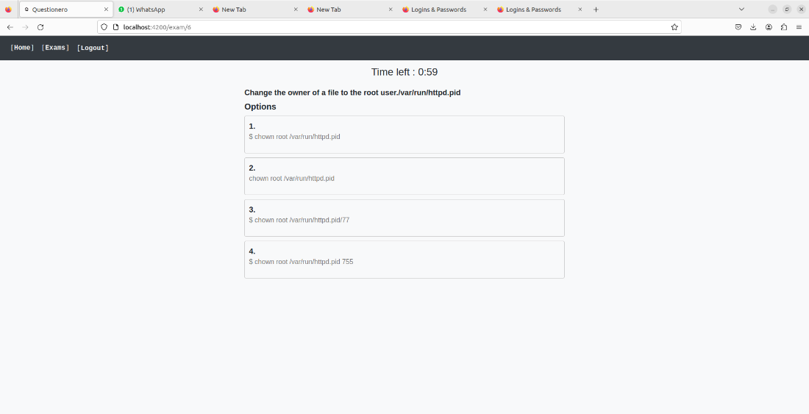

result

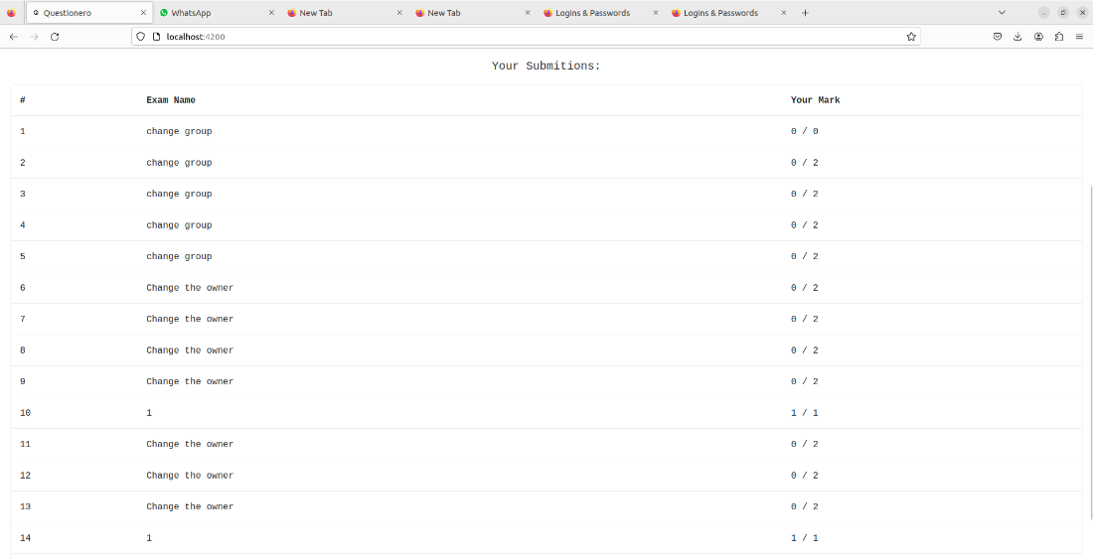

### CHAPTER SIX

### CONCLUSION

#### In summary, our website aims to support individuals in their quest to learn commands, recognizing their significant value in both professional and practical aspects of life. We place utmost emphasis on the importance of this field and aspire to serve as a launching pad for innovative ideas, transforming the conventional examination model, particularly in the realm of programming. Our website will revolutionize knowledge dissemination by prioritizing practical application and testing, enabling rapid learning with minimal effort.

**FUTURE ENHANCEMENTS/PLANS**

The development of our project offers several significant advantages, including: Cross-platform Compatibility: Building a system that works on multiple platforms, such as web, mobile, and desktop, enhances accessibility and allows users to access and use the system on their preferred devices.

Expanded Question Types: Diversifying and increasing the types of questions available in the system provides a richer learning experience for users. By incorporating various question formats, such as multiple-choice, fill in the blanks, and essay-style questions, users can engage with the content in different ways and enhance their understanding.

#### Enhanced User Experience: Improving the user experience is crucial to ensure satisfaction and engagement. By implementing intuitive interfaces, streamlined workflows, and responsive designs, users can navigate the system effortlessly, find what they need easily, and have a seamless and enjoyable experience while interacting with the platform.